Client Information Form
Name:___________________________________________ Phone (_____)________________
Address:___________________________City:__________________State:_____Zip:________
Email____________________________________________________Age:________________
Occupation:_________________________________ Primary Physician:_________________
Emergency Contact:_________________________________Phone:(_____)_______________
How did you hear about Black Hills MFR?_______________________________________
Medical Information /HistoryPlease circle YES or NO. If YES, Please explain
Are You Taking Any Medications ( Yes / No)____________________________________________________
_________________________________________________________________________________________
_________________________________________________________________________________________
Have you had surgery?/Planning to? ( Yes /No )*if yes, include date _________________________________
__________________________________________________________________________________________
__________________________________________________________________________________________
Have you had major OR recent injuries/fractures? (Yes /No)*if yes, includedate ______________________
__________________________________________________________________________________________
__________________________________________________________________________________________
Are you/could you be pregnant? (Yes/No) If yes, how far along? ___________________________________
Please indicate with an (x) if any of the followingapply to you:
___ malignancy ___febrile state (seizures) ___acute circulatory (heart) condition
___aneurysm ___acute rheumatoid arthritis ___sutures
___healing fracture ___neuropathy ___Fibromyalgia
___cellulitis ___systemic or localized infection ___osteomyelitis
___obstructive edema ___open wounds ___hematoma
___advanced diabetes ___Ehlers-Danlos Syndrome ___anticoagulant therapy
___double jointed/ligament laxity ___osteoporosis or advanced degenerative changes
___HIV/AIDS ___hypersensitivity to skin or other skin conditions

Please list any other condition or diagnosis you may have that your therapist needs to be aware of: _________________
_________________________________________________________________________________________________

PLEASE INDICATE AREAS OF PAIN, TENSION AND/OR DYSFUNCTION.
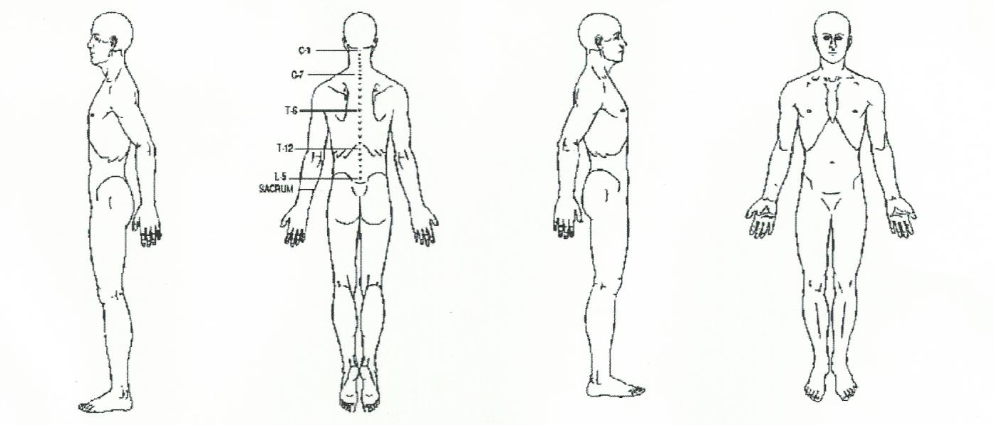
Draw or highlight to show where you feel pain or tension, have limited range of motion
t

Do you suffer from chronic pain? ( Yes /No ) *if yes, please explain (include onset date and event if known) __________________________________________________________________________________________
__________________________________________________________________________________________
What makes it better?__________________________________________________________________
____________________________________________________________________________________
What makes it worse? _________________________________________________________________
____________________________________________________________________________________
Are there any activities that you are unable to perform or are limited in duration and frequency due to pain or decreased range of motion? ( Yes / No ) *if yes please explain _____________________________________ __________________________________________________________________________________________
__________________________________________________________________________________________
What is your goal/desired outcome for the session today? __________________________________________
__________________________________________________________________________________________
__________________________________________________________________________________________
Consent for Treatment
If I experience any pain or discomfort during this session, I will immediately inform the practitioner so adjustments can be made. I further understand that MFR/bodywork should not be construed as a substitute for medical examination, diagnosis, or treatment and that I should see a qualified medical specialist for any mental or physical ailment of which I am aware. I understand that MFR/bodywork practitioners are not qualifiedto diagnose, prescribe, or treat any physical or mental illness, and that nothing said in the course of the session given should be construed as such. Because MFR/bodywork should not be performed under certain medical conditions, I affirm that I have stated all my known medical conditions and answered all questions honestly. I agree to keep the practitioner updated as to any changes in my medical profile and understand that there shall be no liability on the practitioner’s part should I fail to do so. I am aware that I and the practitioner reserve the right to discontinue the session at any time. I understand Black Hills Myofascial Release reserved the right to refuse service at any time. I understand that any illicit or sexually suggestive remarks or advances made by me will result in immediate termination of the session, and I will be liable for payment of the scheduled appointment. Understanding all of this, I give my consent to receive care.

Client Signature:________________________________________________________Date:___________

Parent or Guardian Signature: _____________________________________________Date:___________

